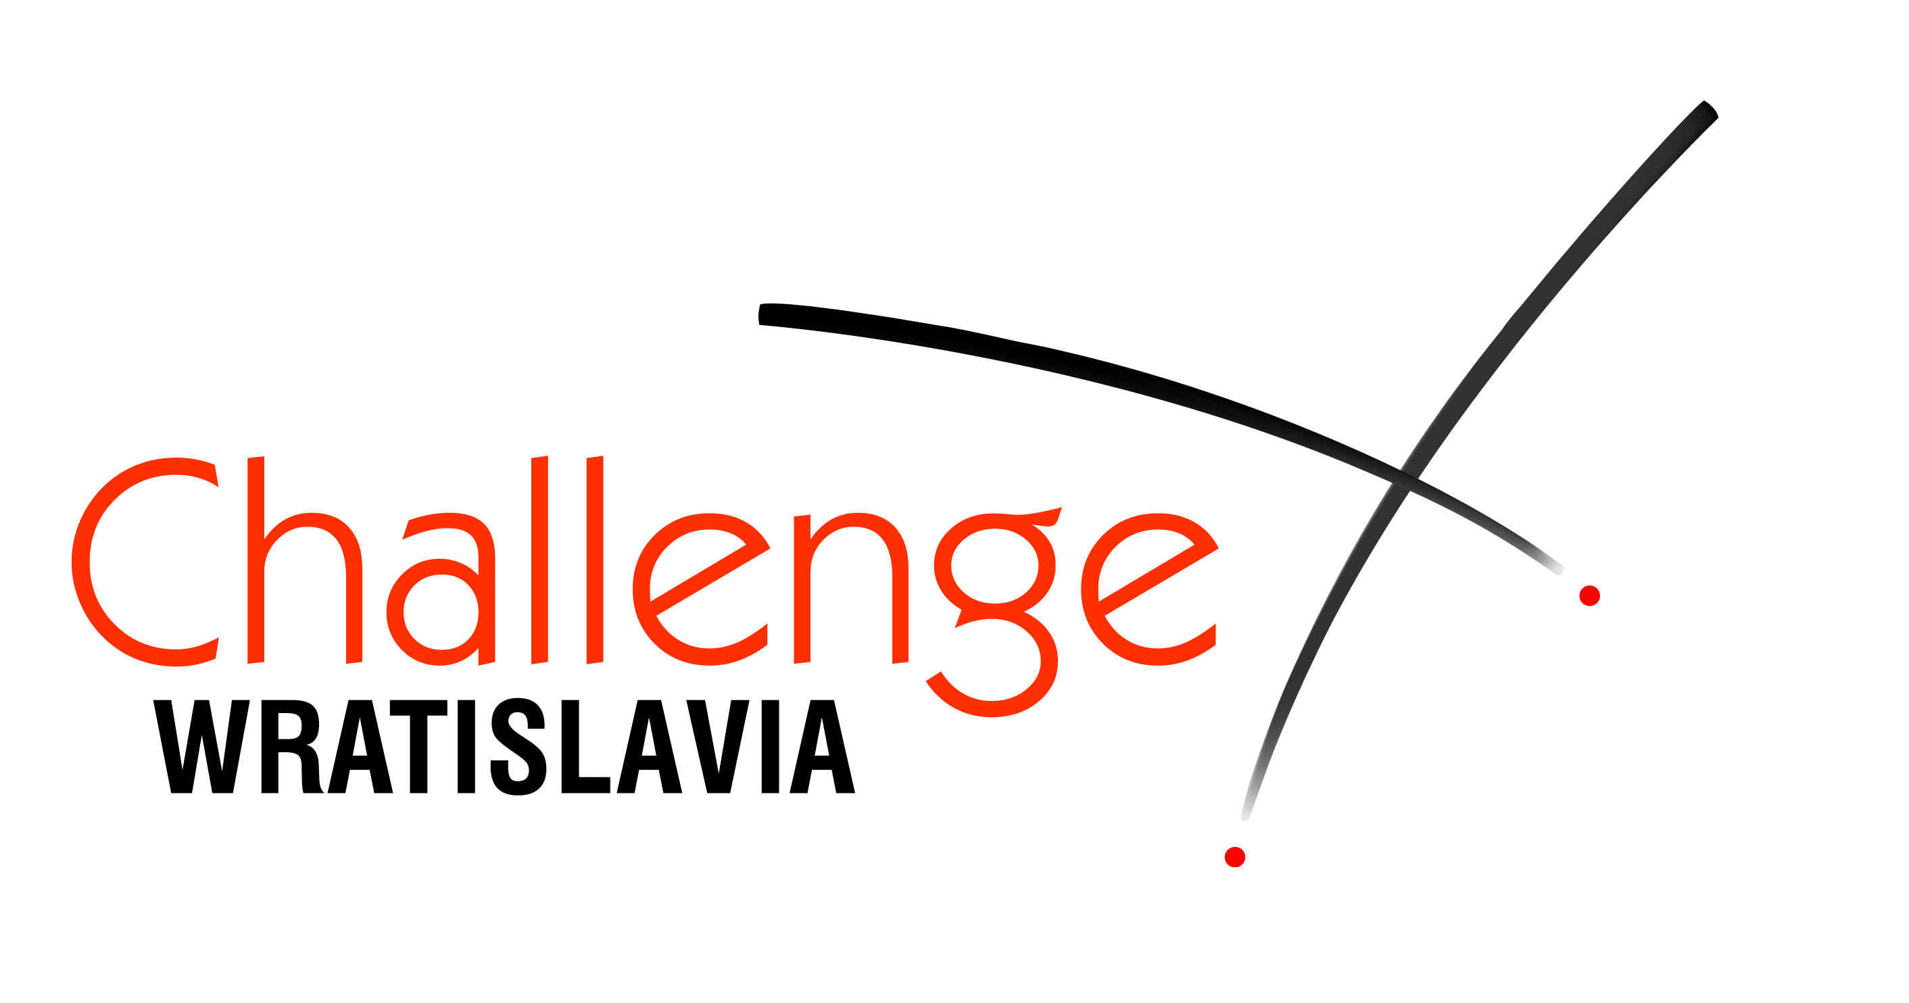
XXXIX International Children’s Fencing Tournament

Challenge Wratislavia

17-21 March 2016

DATES
17-21.03.2016

VENUE
Sport’s Hall ORBITA
2 Wejherowska Str.
Wrocław, POLAND

Participation
Girls and boys born in 2001 and younger
3 age categories in foil, epee and sabre

FORMULA
Poule rounds and direct elimination rounds without repechage

ENTRY FEE
15 euro per person

REGISTRATION
till 11th March, 2016 registered with
registration form via email or fax to Organizer.
confirmed at Organization Committee
45 minutes before the beginning
of the Tournament in the particular category.

REFEREES
Teams with 8 registered participants have to provide 1 referee.

Equipment stall
Nicol, Arthos, Allstar, PBT and others

Accommodation
Hotels recommended by the Organizers could be found on our web.

ORGANIZER
WROCLAWIANIE Fencing Club
phone/fax +48 71 342 13 78
37 Traugutta Str., 50-416 Wroclaw, Poland
wratislavia@wroclawianie.com.pl
www.challengewratislavia.pl

Tournament Agenda

17.03.2016 Girls’ Epee
Thursday
9.00 beginning of bouts 2001-2002
11.00 opening ceremony
11.15 beginning of bouts 2003-2004
12.15 beginning of bouts 2005 and young.
finals

18.03.2016 Boys’ Epee
Friday
9.00 beginning of bouts 2001-2002
11.00 beginning of bouts 2003-2004
12.15 beginning of bouts 2005 and young.
finals

19.03.2016 boys’ foil
Saturday
9.00 beginning of bouts 2001-2002
11.00 beginning of bouts 2003-2004
12.15 beginning of bouts 2005 and young.
finals

20.03.2016 girls’ foil
Sunday
9.00 beginning of bouts 2001-2002
11.00 beginning of bouts 2003-2004
12.15 beginning of bouts 2005 and young.
finals

21.03.2016 girls' sabre and boys’ sabre
Monday
9.00 beginning of bouts 2001-2002
11.00 beginning of bouts 2003-2004
12.15 beginning of bouts 2005 and young.
finals

We wish you a successful start and unforgettable memories of your stay in Wroclaw.
Organizer
www.challengewratislavia.pl

Requirements for fencing clothing and equipment
 | weapon |  |  | mask | plastron | uniform
 | born  2001-2002 | born  2003-2004 | born  2005 and younger
epee | size  5 | size  5 or 2 (825 mm) | size  mini 0 (775 mm) | normal | 800N | 350N
foil | size  5 | size  5 or 2 (825 mm) | size  mini 0 (775 mm) | mask do not need electric bibs | 800N | 350N
sabre | size  5 | size  5 or 2 (820 mm) | size  mini 0 (750 mm) | normal electric | 800N | 350N

