BIRMINGHAM INTERNATIONAL

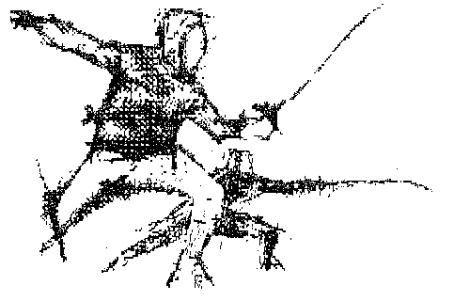
FENCING TOURNAMENT 2016

AT THE UNIVERSITY OF BIRMINGHAM
MUNROW SPORTS CENTRE
Bristol Rd South B15 2TT (A38 South)

Saturday 26 March Men's Foil Check-in closed by 9.00 a.m.
Women’s Foil Check-in closed by11.00 a.m.
Men’s Sabre Check-in closed by 13.30 pm

Sunday 27 March Men's Epee Check-in closed by 9.00 a.m.
British Summer time Women’s Epee Check-in closed by 11.30 a.m.
begins Women’s Sabre Check-in closed 13.30 p.m.

BFA or equivalent N.G.B. licence will be checked.

Entry Fee: £26 per weapon ; Free entry to non-UK visiting fencers (Free entry offer excludes students studying in UK)

Pay cheques to:- “BIFTOC”. Post entries to Organiser address below

Closing date 20 March. Late entries, if agreed, £36.

Prizes for Last 8 fencers at each weapon.

Veterans’ prizes awarded (if status declared on entry )

Special hotel accommodation rates available.

Trade stand, equipment & prizes supported by Leon Paul Equipment Co

Organiser: Mike Whitehouse, BIFTOC Chairman, for England Fencing West Midlands

208 Wheelers Lane, Birmingham B13 0SR telephone/fax +44 121 443 3136
For more information, directions and hotel booking form please look at our web site www.birminghaminternationalfencing.org.uk
or email us : contact@birminghaminternationalfencing.org.uk

The organisers retain the right to change the format of the Tournament at any time.
- - - - - - - - - - - - - - - - - - - - - - - - - - - - - - - - - - - - - - - - - - - - - - - - - - - - - - - - - - -

Name: ......................................................................................................................

Address:....................................................................................................................

Email address:…………………………………………………………………………..

Country: ..................................Club: ...................................BFA/FIE No. ……..

Weapon(s): ...................................Fee Enclosed: ……………Veteran:………..

Referee BFA/FIE : ........................Hotel Form (Yes/No): .............Map………

I understand that the Organising Committee does not accept responsibility for any accident, loss or damage sustained during the Tournament.

Signature ...................................................... (Parent or Guardian if under 18)
Fencers must be aged 13 or over before 01.01.2016 to be allowed to compete

