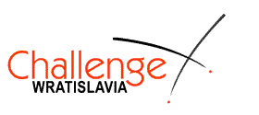
40. Challenge Wratislavia
Wrocław (Poland), 23-27.03.2017
http://www.challengewratislavia.pl/

Registration form

Club
Address (with post code)
Country
Person in charge
E-mail

Participants

No | Surname | Name | Gender  (male or female) | Weapon  (epee, foil, sabre) | Date of birth
1.
2.
3.
4.
5.
6.
7.
8.
Referee
No | Surname | Name | Weapon (epee, foil, sabre)
1
Coach
No | Surname | Name | Mobile
1.
2.

Please send this form via email to wratislavia@wroclawianie.com.pl before March 17th, 2017

