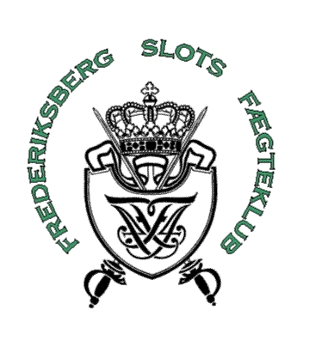

/Fomenko Fencing Academy

INVITATION T0

FREDERIKSBERG FENCING FESTIVAL

Organiser: FFA Fomenko Fencing Academy

Frederiksberg Slots Fægteklub

Time: 4th and 5th of June 2005

Venue: Kedelhallen, Nyelandsvej 75A, 2000 Frederiksberg, Denmark

Idea: The spirit and the concept of the project are reflected by the slogan: “If you fence – you cannot lose.” The tournament will take the form of a real tournament where a winner is found. Simultaneously fencing will be combined with fencing-related games and activities, with the aim to improve the fencer’s ability to perform next time. The opening ceremony will involve all participants in a fencing battle.

Program:

Saturday 4th of June:
09.15: Last registration.
09.30: Opening ceremony – balloon battle (all be dressed in full equipment)
10.00: Start – foil up to 12 year
10.00: Start – epée up to13-15 year
10.00: Start – sabre up to13-15 year
17.00: Finals
18.30: Party.

Sunday 5th of June:
09.15: Last registration
09.30: Start - epée up to 12 year
09.30: Start - foil up to13-15 year
09.30: Start - sabre up to 12 years
14.00: Finals

/Fomenko Fencing Academy/ Fencingmaster Boris Fomenko / Tlf. +45-2267 9210 /fomenko@mail.dk

The Organiser might change the program. Boys and Girls are – depending on the number of participants - to fence separately.

Party:
Saturday night 18 hrs 30 in Kedelhallen. Price: DKK 60 excl. beverages.

Accommodation:
Is possible at Lindevangsskolen, P. G. Ramms Alle 26, Frederiksberg. Price: DKK 33/night. Remember sleeping bag and something soft to sleep on. There will not be organised breakfast at the school. A baker store is nearby.

Hotels can be arranged at a special rate for fencers.

Rules:
FIE.

Entry fee:
DKK 150/person. Participation in more than one discipline costs additionally DKK 50 kr. pr. discipline.

Fair play
Fair play prizes will be given.

Referees:
1-3 participants/day: Not mandatory
4-7 participants/day: 1 referee
8- participants/day: 2 referees.
Clubs unable to bring the required referee must pay a fee of DKK 500 pr. referee pr. day.

Registration:
Latest Monday 23rd of May 2005 to mail: knud_skadborg@hotmail.com

Indicate:
- The fencer’s name, age and discipline (s).
- Responsible leader/coach during the competition.
- Name of referees.
- How many fencers be sleeping at Lindevangsskolen (Friday 3rd of June and Saturday 4th of June)
- If there is a wish for assistance to book hotels at a special fencing rate.
- Contact info (Phone number and email-address).

Phone:
Knud Skadborg: +45-29 24 65 48/+45-36 17 57 66
Boris Fomenko: +45-22 67 92 10/+45-39 64 58 29

/Fomenko Fencing Academy/ Fencingmaster Boris Fomenko / Tlf. +45-2267 9210 /fomenko@mail.dk

