
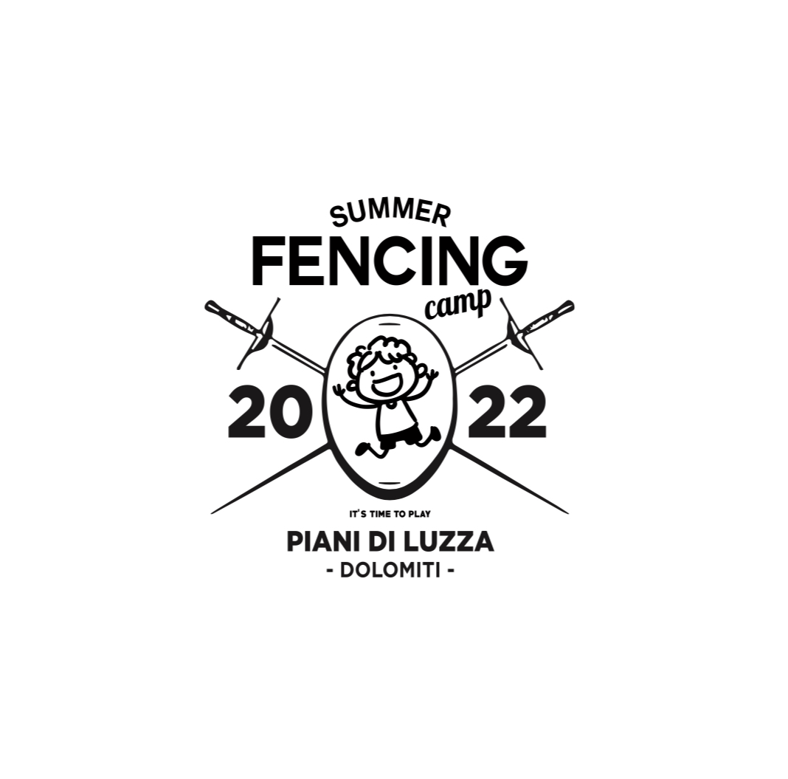

REGISTRATION FORM

To: Management of
Summer Fencing Camp 2022
K.A.: Coach Giuseppe Pierucci

The undersigned _______________________________________ residing in ____________________________________, country __________, __________ citizen, fiscal code number _______________________________________________submits to the Management of the Summer Fencing Camp 2022 the request of registration of our daughter/son to the Camp which takes place:

- from 25 of July to 4 August 2022 Cadets/Juniors/Senior (foil)
- from 4 to 10 of August 2022 Under 14 (foil)
- from 10 to 18 of August 2022 (epee)

(X) Tick the box relating to the category concerned
The location is Bella Italia Efa Village Sport & Family Piani di Luzza (Forni Avoltri – Udine - Italy).
Name: ______________Surname: ________________Date and place of birth: ____________Citizenship:_______________ Residing address:________________ ______________________________________Fiscal code number: _____________Fencing Federation and Fencing Club: _____________Category: _________________
- Main competitions made by the athlete and relevant results attested by the Curriculum attached to this form.

(X) Tick the above box, if applicable

You can find hereby attached the following documents:
- Copy of the wire transfer attesting the payment of the no-refundable deposit of Euro 350,00 (free of charges) for the categories cadets/juniors/seniors and € 300,00 (free of charges) for U14 and Epee. The balance of the price shall be paid at the check-in at Bella Italia facility. The fee includes what has been specified in the brochure.
- Transfer for/to Piani di Luzza from Venezia Airport (Marco Polo)
- Upon the arrival could be made rapid test for Covid-19, the price will be paid on site.
- Copy of Parents and Athlete’s Passport and/or ID Card in force;
- Copy of VISA (if applicable);
- copy of Medical health certificate (for competitions purpose) in force for all stay;
- Information of any Athlete’s allergy/intolerance or medical recommendations;
- Copy of the Health Card/Heath Insurance and/or any equivalent document;
- The waiver (as per standard format which will be provided by the Management of the Fencing Camp) jointly the confirmation of the registration shall be provided within one week from the registration.
In our capacity of Parents, we RELEASE OUR CONSENT to process the sensitive data pursuant the GDPR 2016/679 and subsequent modifications. We are aware that during the event Summer Foil/Epee Camp 2022 will be made ​videos and pictures in which appear underage people, these images will be publicly disclosed and published through social networks.
Place and date_______________

Signature of both parents in readable form
__________________________________________________

