Fencing Guild DE KLAUWAERTS invites you
8th International Sabre competition
girls & boys
The MINI-Claw
Saturday 25 May 2019
Venue: Schermgilde De Klauwaerts,
Clement Heirmanstraat 25,
9100 Sint-Niklaas
Sportzaal Koninklijk Atheneum Sint-Niklaas

Age : Poussins: 2009- and younger ( blade 0 or 2)
Pupillen: 2007-2008 (blade 0 or 2)
Miniemen: 2005-2006 (blade 5)
Cadetten:2002-2003-2004

Wedstrijdschema: Saturday 25 May 2019
Cadetten &Miniemen Pupillen & Poussins
* Oproep: 10u 30 13 u 30
* Scratch: 10 u 45 13 u 45
* Begin: 11u 00 14 u 00

* Finals immediately after each contest
* Valid fencing license compulsory for all participants
* The competition will be fought following the roules of the Vlaamse Schermbond
* Electric fencing scoring during all of the competitions
* entree fee: €15

Liability: The organiser shall not be held responsible for injury or damage of any kind

Inscriptions & information: cramers.kristin@skynet.be till thuesday 21 May 2018

Catering & drinks available at the venue
Fencing shop at venue: SPORFECT (allstar/Uhlmann)

Routebeschrijving schermzaal:
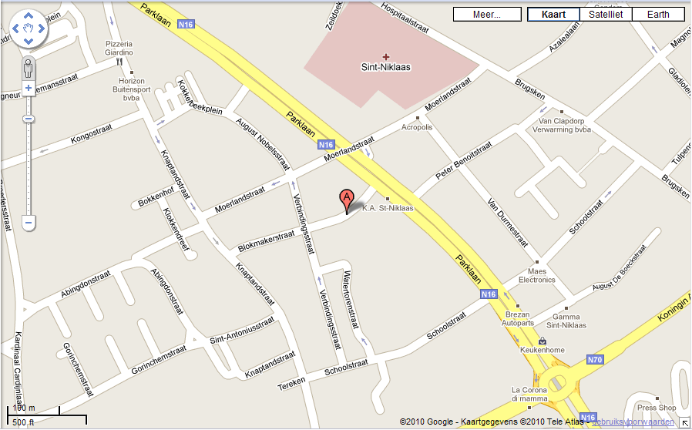
Afrit E17 richting Sint-Niklaas centrum
Door de “tunnel”
Aan de eerste verkeerslichten links ( Moerlandstraat)
Einde van de straat links ( Knaptandstraat)
Eerste straat links ( Blokmakerstraat)
Voorbij de eerste straat rechts aan de rechterkant nr. 25 ( grote poort met daarachter parking!)

