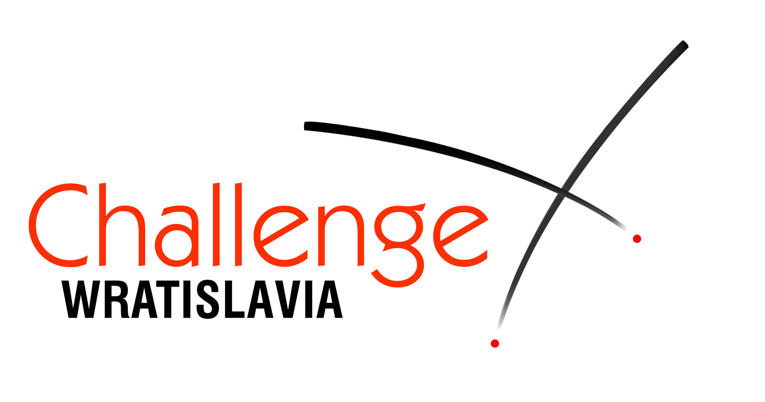
40th International Children’s Fencing Tournament

Challenge Wratislavia

23-27 March 2017

DATES
23-27.03.2017

VENUE
Sport’s Hall ORBITA
2 Wejherowska Str.
Wrocław, POLAND

Participation
Girls and boys born in 2002 and younger
3 age categories in foil, epee and sabre

FORMULA
Poule rounds and direct elimination rounds without repechage

ENTRY FEE
18 euro per person

REGISTRATION
till 17th March, 2017 registered with
registration form via email or fax to Organizer.
confirmed at Organization Committee
45 minutes before the beginning
of the Tournament in the particular category.

REFEREES
Teams with 8 or more registered participants (in one day of the competition) have to provide 1 referee.

Equipment stall
Nicol, Arthos, Allstar, PBT and others

Accommodation
Hotels recommended by the Organizers could be found on our web.

ORGANIZER
WROCLAWIANIE Fencing Club
phone/fax +48 71 342 13 78
37 Traugutta Str., 50-416 Wroclaw, Poland
wratislavia@wroclawianie.com.pl
www.challengewratislavia.pl

Tournament Agenda

23.03.2017 Girls’ Epee
Thursday
9.00 beginning of bouts 2002-2003
11.00 opening ceremony
11.15 beginning of bouts 2004-2005
12.15 beginning of bouts 2006 and young.
finals

24.03.2017 Boys’ Epee
Friday
9.00 beginning of bouts 2002-2003
11.00 beginning of bouts 2004-2005
12.15 beginning of bouts 2006 and young.
finals

25.03.2017 boys’ foil
Saturday
9.00 beginning of bouts 2002-2003
11.00 beginning of bouts 2004-2005
12.15 beginning of bouts 2006 and young.
finals

26.03.2017 girls’ foil
Sunday
9.00 beginning of bouts 2002-2003
11.00 beginning of bouts 2004-2005
12.15 beginning of bouts 2006 and young.
finals

27.03.2017 girls' sabre and boys’ sabre
Monday
9.00 beginning of bouts 2002-2003
11.00 beginning of bouts 2004-2005
12.15 beginning of bouts 2006 and young.
finals

We wish you a successful start and unforgettable memories of your stay in Wroclaw.
Organizer
www.challengewratislavia.pl

Requirements for fencing clothing and equipment
 | weapon |  |  | mask | plastron | uniform
 | U15-born  2002-2003 | U 13-born  2004-2005 | U 11-born  2006 and younger
epee | size  5 | size  5 or 2 (825 mm) | size  mini 0 (775 mm) | normal | 800N | 350N
foil | size  5 | size  5 or 2 (825 mm) | size  mini 0 (775 mm) | mask do not need electric bibs | 800N | 350N
sabre | size  5 | size  5 or 2 (820 mm) | size  mini 0 (750 mm) | normal electric | 800N | 350N

