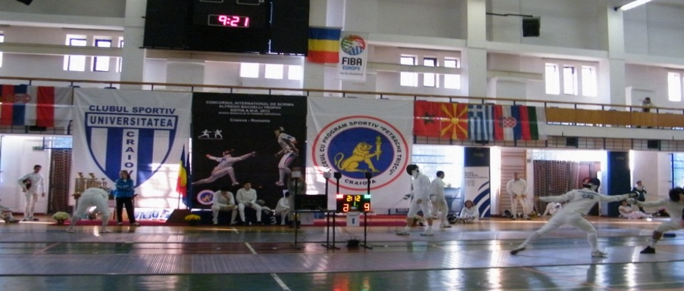
CLUBUL SPORTIV UNIVERSITATEA CRAIOVA AND L.P.S.”PETRACHE TRSICU” HAVE THE PLEASURE TO INVITE YOU TO THE INTERNATIONAL FENCING TOURNAMENT “ALFREDO BACHELLI” TROPHY 2015 – MEN AND WOMEN EPEE

- VENUE : CRAIOVA SPORTS HALL, 32 STIRBEI VODA STREET
- AGE GROUP/WEAPON : SENIOR MEN AND WOMEN EPEE INDIVIDUAL
- DATE : NOVEMBER 07TH 2015
- PARTICIPANTS :

- ORGANISER : CLUBUL SPORTIV « UNIVERSITATEA » CRAIOVA IN PARTNERSHIP WITH « PETRACHE TRSICU » SPORTS HIGHSCHOOL CRAIOVA.
- CONTACT : fanefantezie@yahoo.com (Coaches Radu PODEANU – 0040767470098 and Mircea ALECU - 0040721206089)
- REGISTRATION : E-MAIL REGISTRATION AT - fanefantezie@yahoo.com
- REGISTRATION DEADLINE : NOVEMBER 05TH 2015
- PRIZES : 1ST PLACE – 1500 LEI
2ND PLACE – 1000 LEI
3RD PLACE – 2X500 LEI
9. SCHEDULE OF THE COMPETITION:
7 November 2015 | APPEAL | SCRATCH | BEGINNING
Men`s epee senior individual | 08: 30 | 08: 45 | 09: 00
Women`s epee senior individual | 10: 30 | 10: 45 | 11: 00
10. FORMAT : POULS, DIRECT ELIMINATION, FINALS.
11. TOURNAMENT DELEGATIONS ARE NOT REQUIRED TO PROVIDE REFEREEES.
THE ORGANISER WILL PROVIDE REFEREES FOR ALL STAGES OF THE TOURNAMENT.
12: ACCOMODATION : ALL FOREIGN DELEGATIONS WILL BE ACCOMODATED AT HOTEL PARC - THREE STARS, 12 BIBESCU STREET, CONTACT : hotel-parc-craiova@yahoo.com , 0040251.417.257.
THE ORGANISER WILL PROVIDE ACCOMMODATION FOR 8 PERSONS PER DELEGATION FOR TWO DAYS (6-7 NOVEMBER 2015, BREAKFAST INCLUDED).

2014
