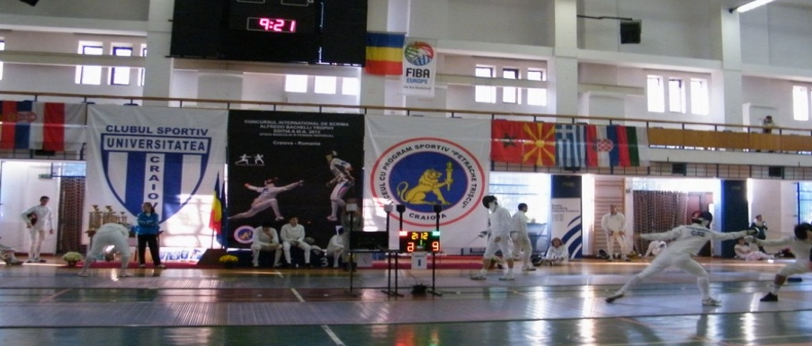
CLUBUL SPORTIV UNIVERSITATEA CRAIOVA AND L.P.S.”PETRACHE TRSICU” HAS THE PLEASURE TO MINVITE YOU TO THE INTERNATIONAL FENCING TOURNEMENT “ALFREDO BACHELLI” TROPHY , 2015 - EPEE FOR MEN AND WOMEN

- VENUE : SPORTS HALL IN THE CITY OF CRAIOVA STR. POLYVALENT HALL. STIRBEI VODA. 32
- AGE GROUP// WEAPON : MEN AND WOMWN EPEE INDIVIDUAL SENIORS
- DATE : NOVEMBER 07. 2015
- PARTICIPANTNS : SENIORS , JUNIORS AND CADETS MINIMUM BORN IN 2000 .
- ORGANIZER : CLUBUL SPORTIV « UNIVERSITATEA » CRAIOVA WITH PARTENER SPORT LYCEUM « PETRACHE TRSICU » CRAIOVA.
- CONTACTS : fanefantezie@yahoo.com ; alecuelena2000@yahoo.com ( Antr. Radu PODEANU -0040767470098, Mircea ALECU-0040721206089 )
- REGISTRATION : REGISTRATION CAN - E-MAIL fanefantezie@yahoo.com
- REGISTRATION DEADLINE : NOVEMBER 05 TH 2015
- PRIX : 1. PLACE 1500 LEI
2. PLACE 1000 LEI
- PLACE 2X500 LEI
10. SCHEDULE OF THE COMPETITION:
7 th of november 2015 | APEEL | SCRATH | BEGINNING
Men ‘s epee senior | 8: 30 | 8: 45 | 9: 00
Women ‘s epee senior | 10: 30 | 10: 45 | 11:00
11. FORMAT : POULS , DIRECT ELIMINATION FINALES FOUR.
TOURNAMENT.DELEGATIONS ARE NET REGISTRED TO PROVIDE REFREEES. RIFREEES OF THE GROUPS ,THE DIRECT ELIMINATIONS AND THE FINALS WIL BE THE PARTICIPANS THEMSCLVES OR MEMBERS OF THE DELEGATIONS,HEAVING THE SKILLS OF A REFEREE.
12. ACCOMODATION :TO ALL FOREIGN DELEGATION IS PROVIDED AT THE HOTEL PARK-THREE STARS, STREET GH. BIBESCU ,
13. HOTEL CONTACT INFO: hotel-parc-craiova@yahoo.com , 0040251.417.257.THE ORGANIZER ARRANGE ACCOMMODATION FOR 8 PERSONS TWO DAY / 6-7 NOVEMBER 2015 HOTEL - BREAKFAST .

2014

