

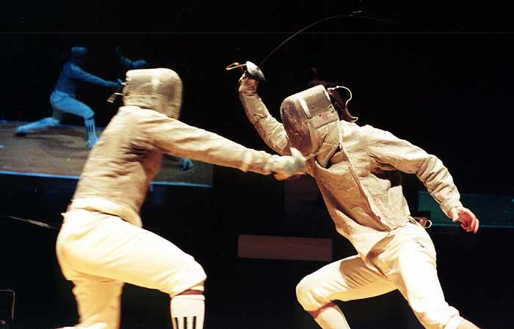

MEN’S SABRE INDIVIDUAL.(WITH WORLD CUP POINTS)
WOMEN’S SABRE INDIVIDUAL.
TEAM SABRE.

Dates. 21 June 2003
09:00 –10:00 am Men’s Individual Registration.
09:00 – 10:15 am Weapon Control.
10:30am Men’s pre-competition.(1st round)
17-00 pm FINAL

22 June 2003
09:00 – 09:45 am Women’s Individual Registration.
09:00 – 10:00 am Weapon Control.
10:15am Women’s pre-competition.
15-00 pm FINAL.

TEAM COMPETITION
10:30 am Registration.
11:00 am Start.

NEW VENUE. The Sports Centre, University of Northumbria,
Off Northumberland Road. Newcastle upon Tyne. NE1 8ST

ENTRY FEE.

ENTRY FEE FOR BRITISH COMPETITIORS AND BRITISH BASED OVERSEAS FENCERS £15-00 (Male and Female) (SABRE CLUB MEMBERS £10-00) FOREIGN FENCERS FREE.

ENTRY FEE FOR TEAM EVENT £15-00
TEAMS MAY BE ENTERED ON THE DAY.

CHEQUES TO BE MADE PAYABLE TO SALLE JAKAB
C/O Beech Law, New House Farm,
Kiln Pit Hill,
Consett.
County Durham. DH8 9LR.
England.
Tel/Fax +44 (0) 1207 255 214.

AN INFORMATION SHEET AND ENTRY FORM FOR COMPETITORS IS ATTACHED
DRUG AND ALCOHOL TESTING MAY TAKE PLACE AT THIS COMPETITION.
REGULATIONS. (MEN’S INDIVIDUAL) FIE Regulations regarding clothing must be observed. 800 Newton clothing, 1600 Newton mask bib. Plastrons must be worn. Names and National colours must be worn from the Last 32 onwards.
Blades must be stamped S 1999/2000/2001/2002

FIE LICENCES. FIE Licences are MANDATORY for all the Men’s Individual Coupe du Nord Competitions. (licences will be checked)

WOMENS INDIVIDUAL 350 or 800 Newton clothing. FIE licences are not required.

TRANSPORT
Main Airport. Newcastle International.
From the Airport. A metro service runs every 15 minutes to the City centre.

From North Seas Ferry. Taxis are available from the Ferry
landing to the venue on the morning of the competition.
The Rail Station is within 10 minutes of the venue.

*************ACCOMMODATION.***************
There is a major corporate sports event on in the city, so it is advisable to make accommodation arrangements now. Phone tourist information Tel: =44 (0)191 2778000

********* CAR PARKING.*********
As the new venue is a city centre site, parking is a problem. A total of 30 spaces have been reserved directly opposite the venue. If you intend travelling by car, please contact me re a permit and directions/maps
E-MAIL barry.flood@lineone.net or telephone 01207 255214

SPONSORSHIP.
The Organisers wish to thank the following Sponsors: -

AYCLIFFE ENGINEEERING, NEWTON AYCLIFFE.

THE UNIVERSITY OF NORTHUMBRIA at NEWCASTLE upon TYNE.

LEON PAUL EQUIPMENT COMPANY Ltd.

SALLE JAKAB FENCING CLUB.

ENTRY FORM FOR BRITISH BASED FENCERS ONLY.

Name. ____________________________________

First Name ________________________________

Address_______________________________________________________

Post Code._______________Telephone Number_____________________

E-Mail address___________________________________________________

Signature__________________________________(Parent/Guardian if Under 18)

Cheque made payable to SALLE JAKAB for £___________ enclosed

