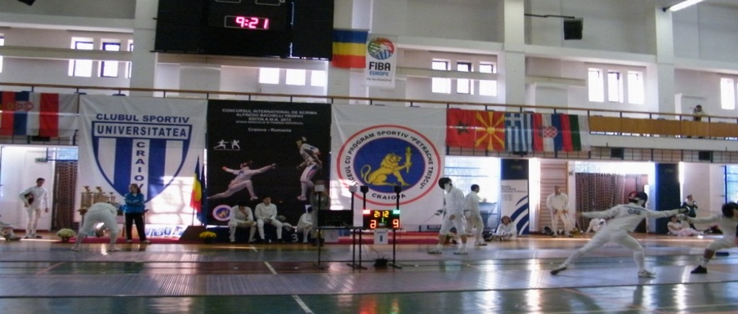
6CLUBUL SPORTIV UNIVERSITATEA CRAIOVA AND L.P.S.”PETRACHE TRSICU” HAVE THE PLEASURE TO INVITE YOU TO THE INTERNATIONAL FENCING TOURNAMENT “ALFREDO BACHELLI” TROPHY 2016 – MEN AND WOMEN EPEE

- VENUE : CRAIOVA SPORTS HALL , 32 STIRBEI VODA STREET
- AGE GROUP/WEAPON : SENIOR MEN AND WOMEN EPEE INDIVIDUAL
- DATE : NOVEMBER 06TH 2016
- ORGANISER : CLUBUL SPORTIV « UNIVERSITATEA
- CRAIOVA IN PARTNERSHIP WITH « PETRACHE TRSICU » SPORTS HIGHSCHOOL CRAIOVA.
- CONTACT : fanefantezie@yahoo.com (Coaches Radu PODEANU – 0040767470098 and Catalin BRANDUSOIU 0040740132374)
- REGISTRATION : E-MAIL REGISTRATION AT - fanefantezie@yahoo.com, catalin_brandusoiu@yahoo.com
- REGISTRATION DEADLINE : OCTOMBER 28TH 2016
- PRIZES : 1ST PLACE – 1500 LEI
2ND PLACE – 1000 LEI
3RD PLACE – 2X500 LEI
9. SCHEDULE OF THE COMPETITION:
6 November 2016 | APPEAL | SCRATCH | BEGINNING
Men`s epee senior individual | 08: 30 | 08: 45 | 09: 00
Women`s epee senior individual | 10: 30 | 10: 45 | 11: 00
10. FORMAT : POULS, DIRECT ELIMINATION, FINALS.
11. TOURNAMENT DELEGATIONS ARE NOT REQUIRED TO PROVIDE REFEREEES.
THE ORGANISER WILL PROVIDE REFEREES FOR ALL STAGES OF THE TOURNAMENT.
12: ACCOMODATION : ALL FOREIGN DELEGATIONS WILL BE ACCOMODATED AT HOTEL PARC - THREE STARS, 12 BIBESCU STREET, CONTACT : hotel-parc-craiova@yahoo.com , 0040251.417.257.
THE ORGANISER WILL PROVIDE ACCOMMODATION FOR 8 PERSONS PER DELEGATION FOR TWO DAYS (5-6 NOVEMBER 2016, BREAKFAST INCLUDED).

2015
